**Alternative Beekeeping for Beginners**

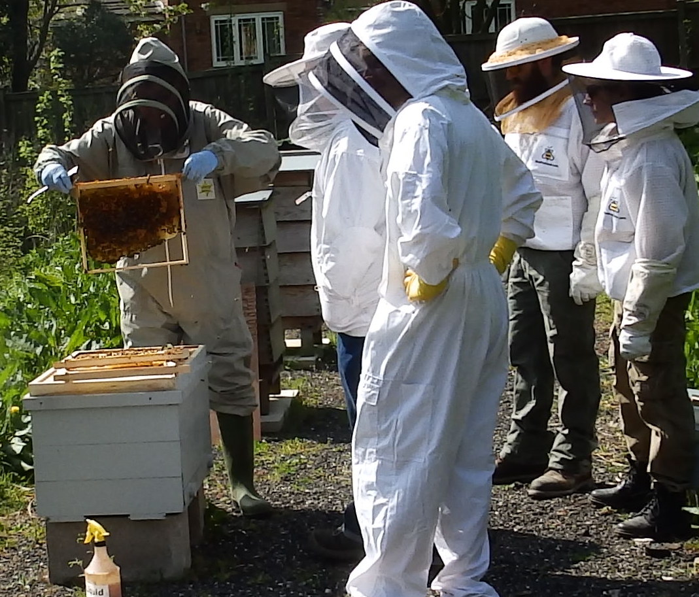

**If you have ever thought of owning a colony of honey bees but have been deterred by not knowing exactly what is involved, or how much time it might take, then this course is for you! This popular, one day, inter-active workshop, organised by Lune Valley Community Beekeepers, focuses on responsible, low intervention, bee-centric approaches to beekeeping and covers all you need to know and consider before you start keeping bees.**

**Sunday, 21st March, 2021**

**9-30am to 4-00pm**

**The Village Hall, Aughton, Lancaster LA2 8LU**

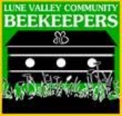

**For further details or to book a place visit**

[**www.lunevalleybeekeepers.co.uk**](http://www.lunevalleybeekeepers.co.uk)

**or telephone 01525 811978**

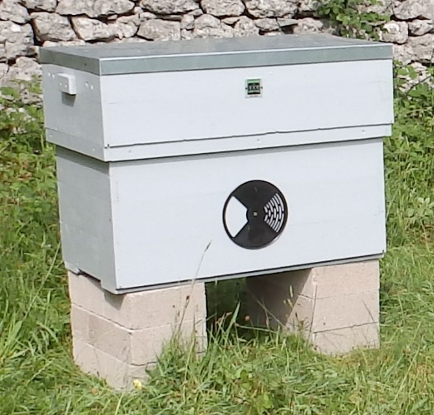**ALTERNATIVE BEEKEEPING**

**FOR BEGINNERS**

**21st March,2021**

If you have ever thought of owning a colony of honey bees but have been deterred by not knowing exactly what is involved, or how much time it might take, then this course is for you!

This one-day, inter-active workshop focuses on responsible, environmentally friendly, low intervention, bee-centric approaches to beekeeping and will cover all you need to know and consider before keeping bees.

The workshop takes place on **Sunday, 21st March 2021** In Aughton Village Hall (LA2 8LU) from 09-30am to 4-00pm and covers the following topics:

|  |  |
| --- | --- |
| * Why keep bees? * Recognising bees, wasps and hornets * Brief history of beekeeping * Life cycle of the honey bee * Hives and equipment * Honey extraction | * An alternative approach * Creating an apiary * Bees, the Law and Insurance * Bee stings * Acquiring bees * The beekeeping Year |

The cost is £60 per person which includes comprehensive notes (50-page booklet), lunch and refreshments throughout the day.

**To book a place please complete the following booking form**

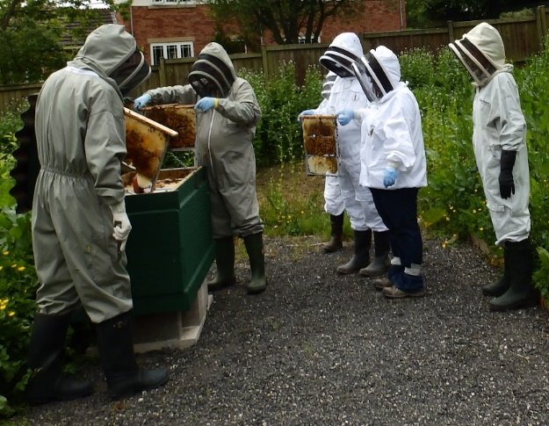A further workshop will be held on in May 2021 at the Club’s Apiary, Nazareth House, Lancaster which will introduce you to active colonies of bees housed in a variety of different types of long hive and provide you with the opportunity to handle bees for yourself under expert guidance. You will also be taught practical skills including apiary safety and hygiene, frame building and the use of smoke. Full protective equipment will be provided, although you will have to provide your own wellies**.**

Further details of this workshop will be provided at the first workshop.

|  |  |  |  |
| --- | --- | --- | --- |
| **LUNE VALLEY COMMUNITY BEEKEEPERS**  **BOOKING FORM**  **ALTERNATIVE BEEKEEPING FOR BEGINNERS**  **Sunday, 21st March, 2021** | | | |
| Title: | Name: | | |
| Address: | | | |
| Post Code: | | Telephone: | |
| Email address: | | | |
| Name(s) of people attending with me: | | | |
| **No of places** | | **Course fee** | **Amount Due** |
|  | | £60  Per person |  |
| Please indicate method of payment | | Cheque/BACS/Cash | |
| Bank details for BACS payment  ***Please quote your name as the payment reference to help us identify the payments.*** | | Lune Valley Community Beekeepers  Account number – 29993268  Sort code 77-26-17 | |
| Signed: | | Date: | |
| **Gift Aid declaration (for tax payers only)***–* past, present & future donations  Please treat this payment as a Gift Aid donation. I confirm I have paid or will pay an amount of Income Tax and/or Capital Gains Tax for the current tax year (6 April to 5 April) that is at least equal to the amount of tax that all the charities and Community Amateur Sports Clubs (CASCs) that I donate to will reclaim on my gifts for the current tax year. I understand that other taxes such as VAT and Council Tax do not qualify. I understand the charity will reclaim 25p of tax on every £1 that I have given.  **Lune Valley Community Beekeepers – HMRC Charities Reference EW55082** | | | |
| Signed: | | Date: | |
| **Please either email this form to** [**fred@lunevalleybeekeepers.co.uk**](mailto:fred@lunevalleybeekeepers.co.uk) **or post it together with your course fee(s) to: LVCB, High Tarn, Aughton, Lancaster, LA2 8LU.** | | | |